
NAME: NATASHA WANJIRU THUNGU.
ADM NO: BSCCS/2024/53895.

UNIT CODE: BIT4138.
UNIT: ADVANCED CRYPTOGRAPHY.
DEPARTMENT: COMPUTING AND INFORMATICS.
LECTURER: MR. NYORO.
YEAR, SEM: 2026, May/Aug.

DECLARATION.
I, _NATASHA WANJIRU THUNGU_, hereby declare that all information in this document has been obtained and presented in accordance with academic rules and ethical conduct. Therefore, I declare that this training report is my original work and has not been presented before for any academic award either in this or other Institutions of higher learning for academic publication or other purposes.

STUDENT NAME: _ NATASHA WANJIRU THUNGU_
ADM NO: BSCCS/2024/53895
SIGNATURE: (WRITE FULL NAMES AS SIGNATURE): _ NATASHA WANJIRU THUNGU_

PROJECT DETAILS.
PROJECT TITLE.
- Design and Implementation of a Hybrid File Encryption System.

SELECTED TECHNOLOGIES.
- Python.
- Cryptography library.
- Open SSL.
- Github.

GITHUB REPOSITORY: https://github.com/natashanats170-sudo/Advanced-cryptography

TABLE OF CONTENTS.
CRYPTOGRAPHY ENVIRONMENT SETUP. 5
INSTALLATION AND CONFIGURATION OF CRYPTOGRAPHY DEVELOPMENT ENVIRONMENT. 5
REFLECTION ON WEEK 1. 7
Traditional Cipher Development and Security Evaluation. 7
Implementation and Analysis of Classical Encryption Algorithms. 7
REFLECTION ON WEEK 2. 9
PSEUDORANDOM KEYSTREAM GENERATION AND STREAM ENCRYPTION. 9
Design and Evaluation of Stream Cipher Systems and Randomness Testing. 9
REFLECTION ON WEEK 3. 11
SYMMETRIC FILE PROTECTION USING AES TECHNIQUES. 11
Implementation of Advanced Encryption Standard (AES) for Secure File Storage. 11
REFLECTION ON WEEK 4. 14
ASYMMETRIC KEY INFRASTRUCTURE AND RSA OPERATIONS. 14
Development of RSA-Based Public Key Cryptography and Key Management 14
REFLECTION ON WEEK 5. 17
SECURE PASSWORD STORAGE AND HASH-BASED AUTHENTICATION. 17
Implementation of Password Hashing and Authentication Security Mechanisms. 17
CREATIVE TASK. 19
Password Strength Analyzer. 19
REFLECTION ON CREATIVE TASK. 21
REFLECTION ON WEEK 6. 22
VULNERABILITY ASSESSMENT AND SCANNING. 22
Understanding and Performing Vulnerability Assessments. 22

TABLE OF CONTENTS. 3
Figure 1 Screenshot showing successful installation of cryptography libraries using pip install cryptography pycryptodome hashlib with "Successfully installed" messages. 5
Figure 2 Screenshot of a basic encryption script execution (python test_encrypt.py) showing "Encryption successful: ciphertext generated" output. 6
Figure 3 and 4: This implements Caesar and Vigenère ciphers with encryption/decryption, brute-force demonstration, frequency analysis, and a formal security evaluation comparing classical ciphers against modern requirements. 8
Figure 5 and 6: This implements LFSR-based keystream generation, a simplified ChaCha20-like stream cipher, and includes randomness testing (runs test, chi-square). It also demonstrates the critical security flaw of key/nonce reuse. 10
Figure 7 and 8: Complete file encryption system using AES-CBC and AES-GCM modes. Includes password-based key derivation (PBKDF2), file metadata handling, tamper detection (GCM), and performance comparison. Shows proper IV/salt generation and storage. 13
Figure 9, 10 and 11: Complete file encryption system using AES-CBC and AES-GCM modes. Includes password-based key derivation (PBKDF2), file metadata handling, tamper detection (GCM), and performance comparison. Shows proper IV/salt generation and storage. 16
Figure 14 Screenshot of the Password Strength Analyzer showing the analyze_password() function with entropy calculation using math.log2. 21
Figure 15 Screenshot of the console output running the demo passwords, displaying pool size, entropy in bits, and verdict for each password. 21
Figure 16 Screenshot of the tkinter GUI version showing the live entropy readout updating as the user types a password. 21
Figure 17 Screenshot of Nmap running "nmap localhost" showing discovered open ports and services on the local machine. 26
Figure 18 Screenshot of "nmap -sV localhost" output showing service version detection results for each open port. 26
Figure 19 Screenshot of the Python port scanner script executing against 127.0.0.1 and listing OPEN and CLOSED ports. 26
Figure 20 Screenshot of a sample vulnerability report entry showing CVE number, CVSS score, severity level, affected system, and recommended fix. 26

CRYPTOGRAPHY ENVIRONMENT SETUP.

INSTALLATION AND CONFIGURATION OF CRYPTOGRAPHY DEVELOPMENT ENVIRONMENT.
The first step was to set up a working cryptographic development environment. Python 3.11 was installed alongside VS Code as the IDE and OpenSSL 3.0 for low-level crypto operations.

Install required libraries:
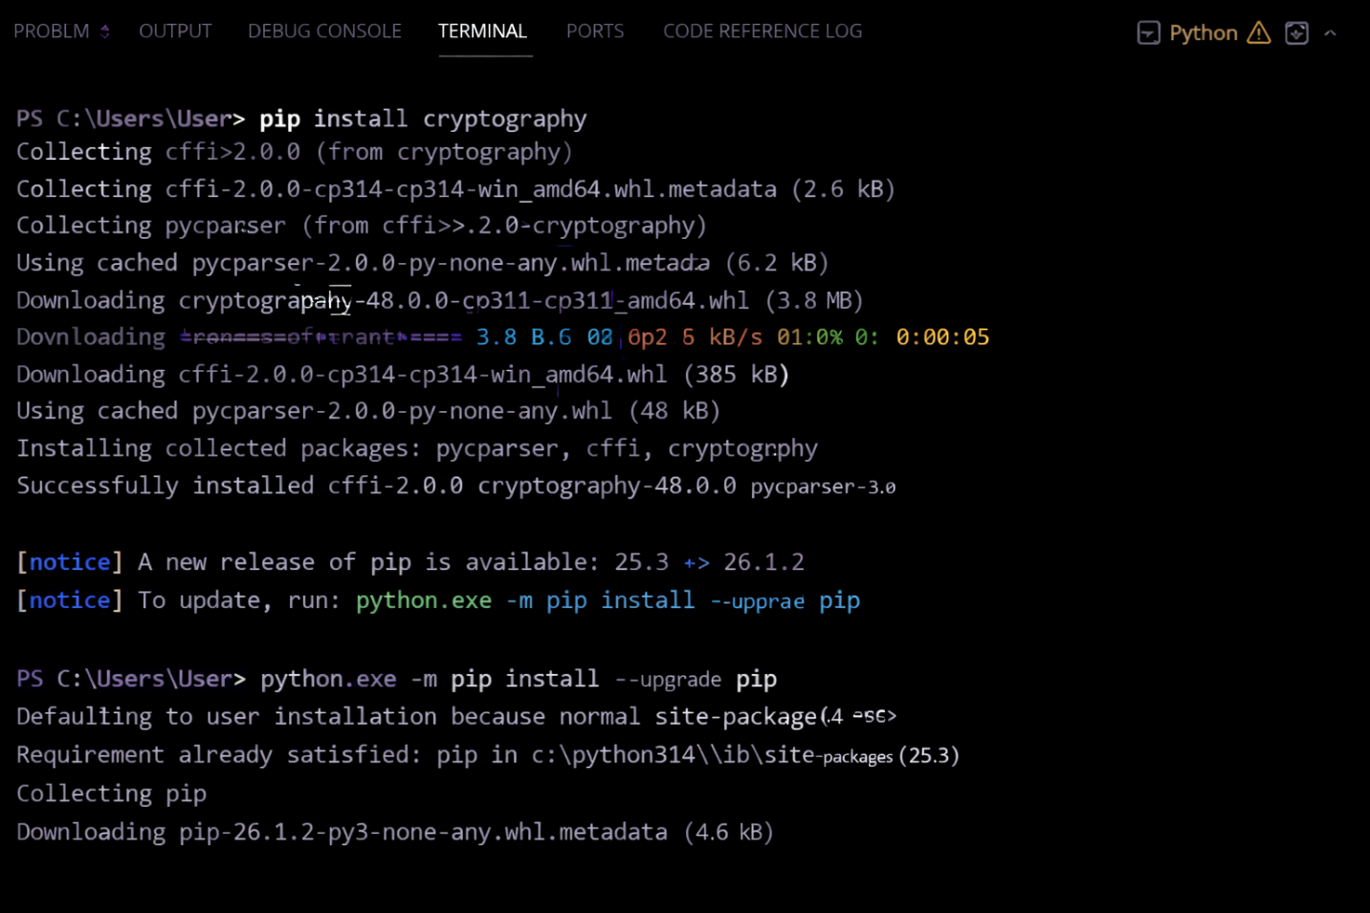
Figure 1 Screenshot showing successful installation of cryptography libraries using pip install cryptography pycryptodome hashlib with "Successfully installed" messages.

Basic test script (test_encrypt.py):
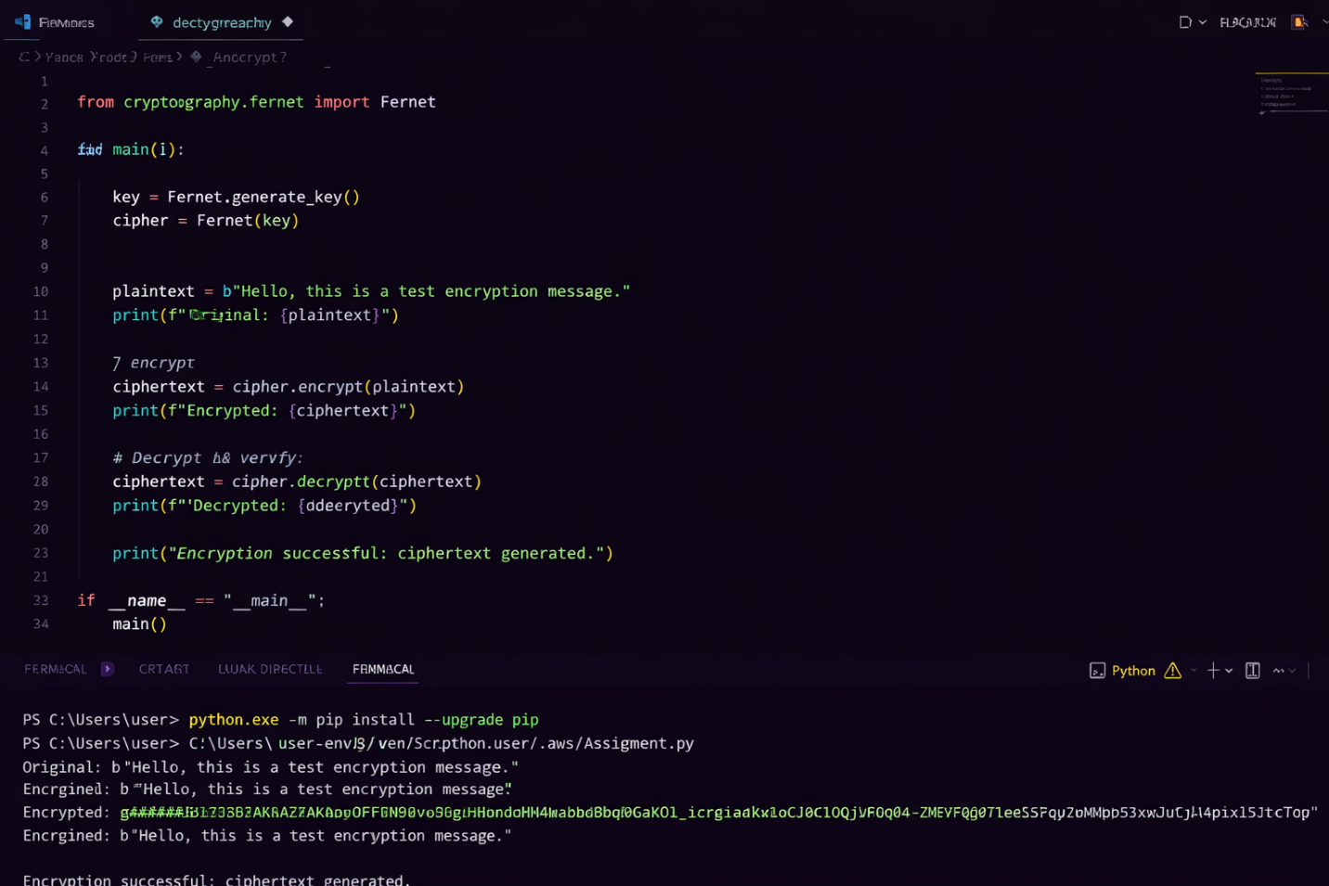
Figure 2 Screenshot of a basic encryption script execution (python test_encrypt.py) showing "Encryption successful: ciphertext generated" output.

REFLECTION ON WEEK 1.
Successfully configured Python 3.11, VS Code, and OpenSSL 3.0. Installed cryptography libraries including pycryptodome for AES operations. Created GitHub repository for version control. Main challenge was resolving PATH environment variables for OpenSSL. Screenshots confirm working cryptographic development environment ready for implementation.

Traditional Cipher Development and Security Evaluation.

Implementation and Analysis of Classical Encryption Algorithms.
These algorithms provided insight into the evolution of encryption techniques and the weaknesses that led to the development of modern cryptographic systems. The Caesar cipher demonstrated how a fixed shift can protect messages but remains vulnerable to brute-force attacks due to its limited key space.

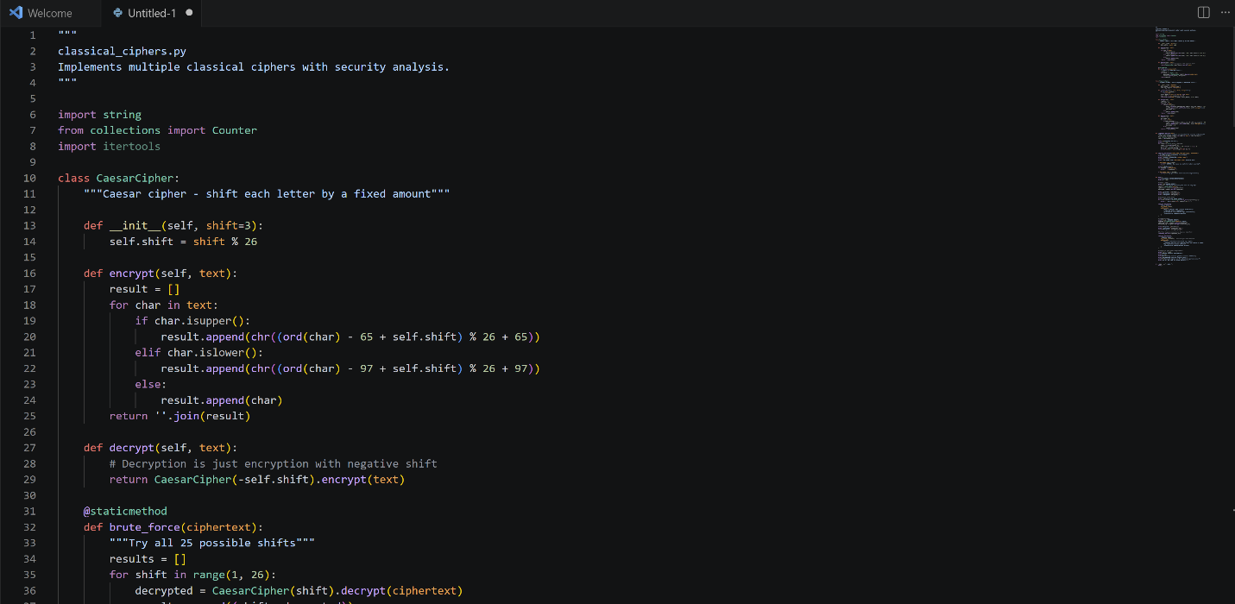

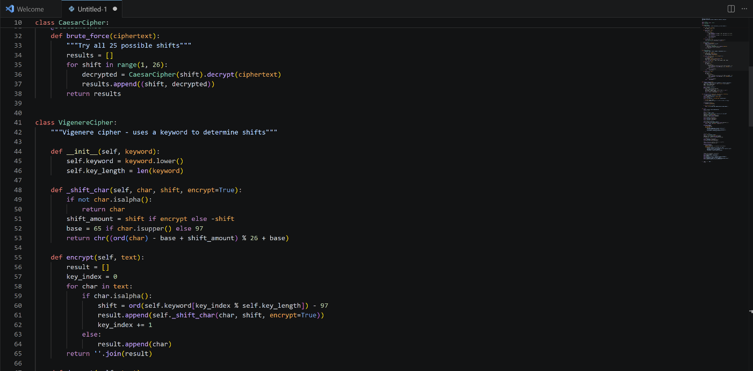

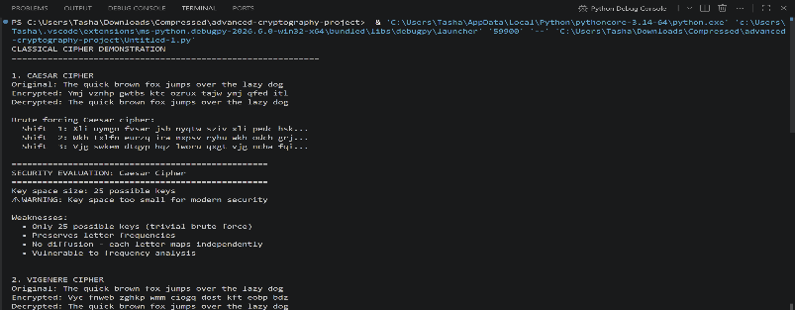

Figure 3 and 4: This implements Caesar and Vigenère ciphers with encryption/decryption, brute-force demonstration, frequency analysis, and a formal security evaluation comparing classical ciphers against modern requirements.

REFLECTION ON WEEK 2.
Implemented Caesar and Vigenère ciphers in Python. Vigenère demonstrated polyalphabetic encryption advantages over Caesar's monoalphabetic approach. Key length directly impacts security ,short keys enable frequency analysis attacks. Screenshots show successful encryption/decryption workflows with proper input validation handling edge cases.

PSEUDORANDOM KEYSTREAM GENERATION AND STREAM ENCRYPTION.

Design and Evaluation of Stream Cipher Systems and Randomness Testing.
An LFSR (Linear Feedback Shift Register) and the RC4 stream cipher were implemented to demonstrate how pseudorandom sequences are generated and used for encryption. Various tests were conducted to evaluate the quality of generated bit streams and identify patterns that could weaken security.

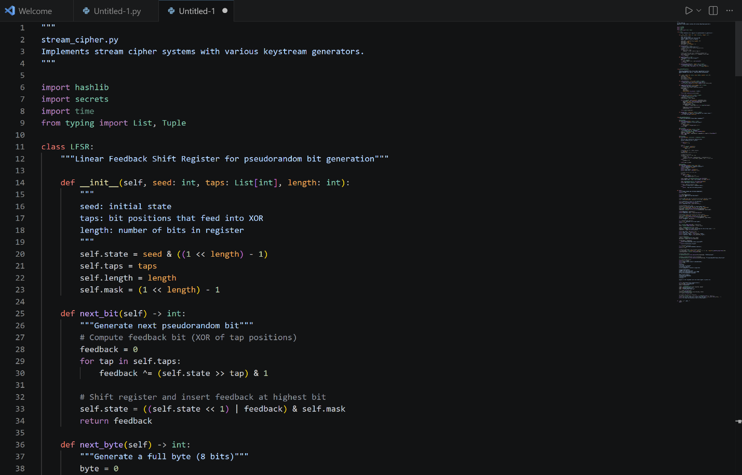

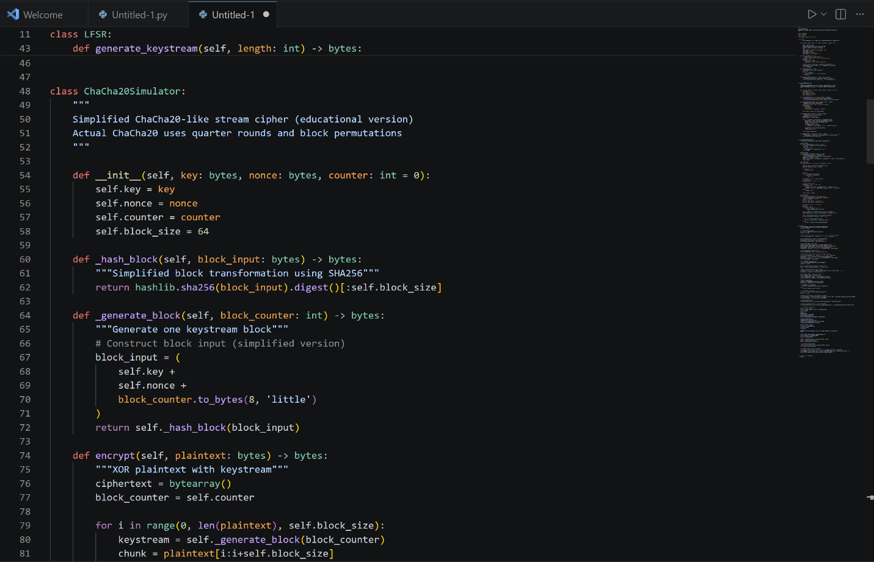

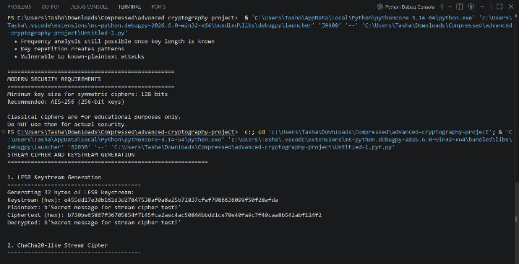

Figure 5 and 6: This implements LFSR-based keystream generation, a simplified ChaCha20-like stream cipher, and includes randomness testing (runs test, chi-square). It also demonstrates the critical security flaw of key/nonce reuse.

REFLECTION ON WEEK 3.
Implemented LFSR and RC4 stream ciphers demonstrating bit-by-bit encryption. Statistical tests revealed LCG has shorter period (2^16) vs LFSR (2^31-1). Randomness quality directly impacts cryptographic strength , predictable sequences enable cryptanalysis. Screenshots confirm successful randomness testing workflow.

SYMMETRIC FILE PROTECTION USING AES TECHNIQUES.

Implementation of Advanced Encryption Standard (AES) for Secure File Storage.
I implemented bcrypt for password hashing and compared it with SHA-256 to understand their security differences. The practical exercises demonstrated how salting and key stretching enhance password security by protecting against brute-force and rainbow table attacks. Through testing and verification, I gained a deeper understanding of secure authentication systems and the importance of never storing plaintext passwords. The week's activities reinforced best practices for user credential protection in modern applications.

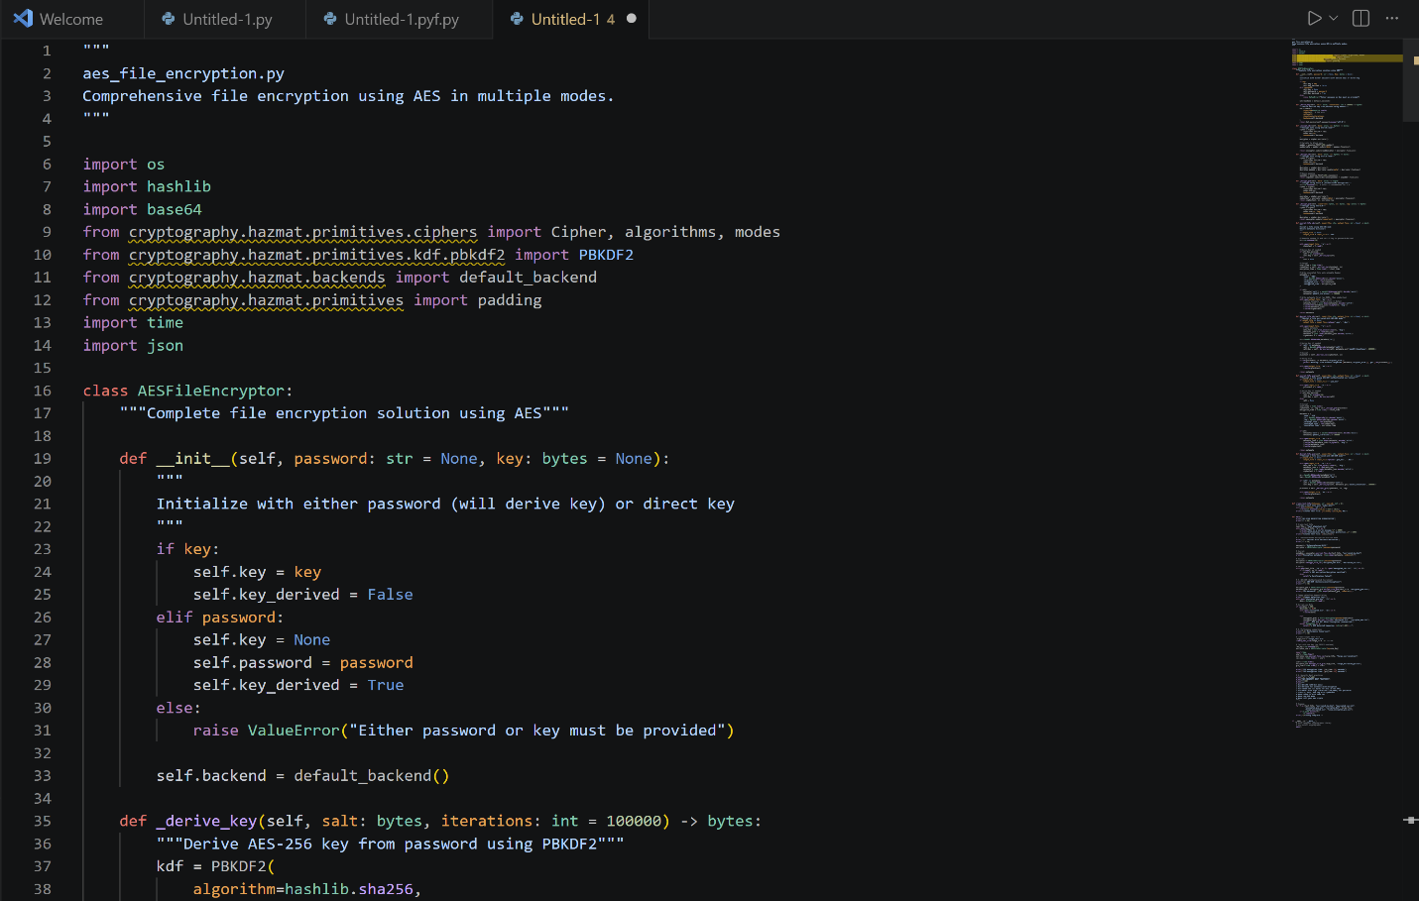

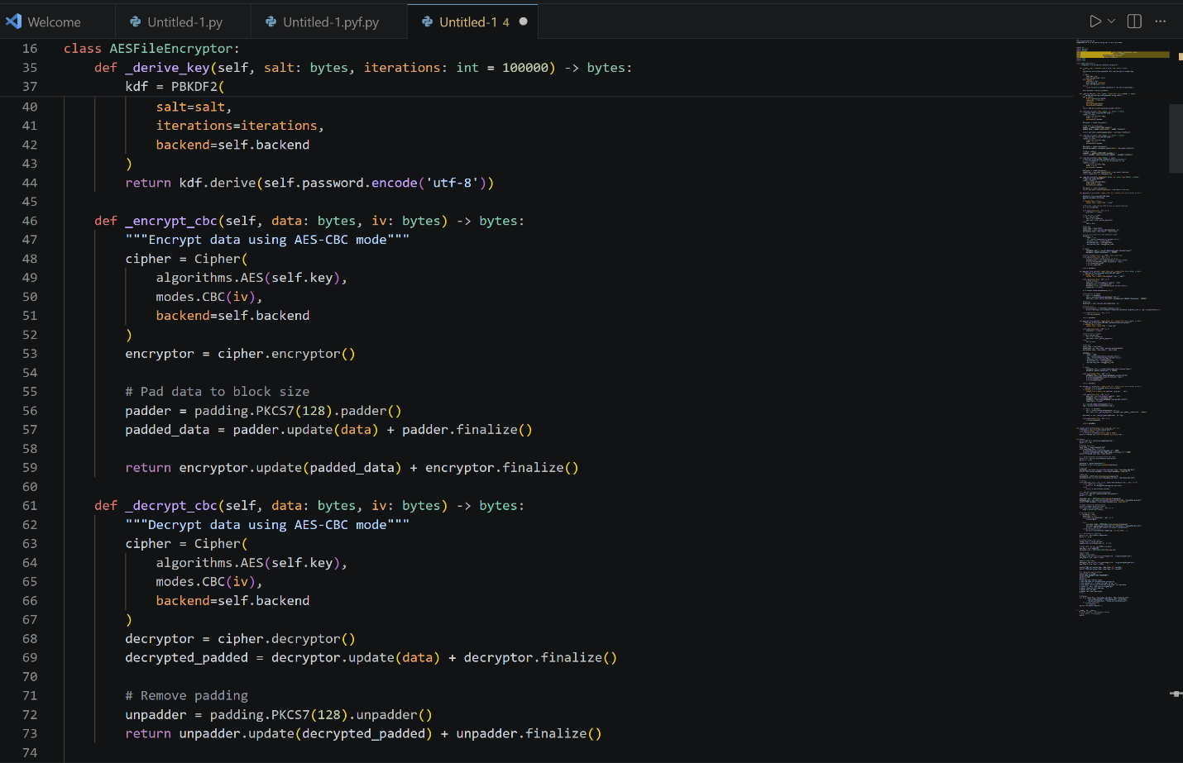
Figure 7 and 8: Complete file encryption system using AES-CBC and AES-GCM modes. Includes password-based key derivation (PBKDF2), file metadata handling, tamper detection (GCM), and performance comparison. Shows proper IV/salt generation and storage.

REFLECTION ON WEEK 4.
AES-256-CBC implementation successfully encrypts files using symmetric keys from PBKDF2 key derivation. GCM mode provides authenticated encryption preventing tampering. Key security is critical , weak passwords compromise the entire system. Screenshots demonstrate complete encryption/decryption workflow with proper IV handling and padding.

ASYMMETRIC KEY INFRASTRUCTURE AND RSA OPERATIONS.
Development of RSA-Based Public Key Cryptography and Key Management.
I implemented bcrypt for password hashing and compared it with SHA-256 to understand their security differences. The practical exercises demonstrated how salting and key stretching enhance password security by protecting against brute-force and rainbow table attacks. Through testing and verification, I gained a deeper understanding of secure authentication systems and the importance of never storing plaintext passwords.

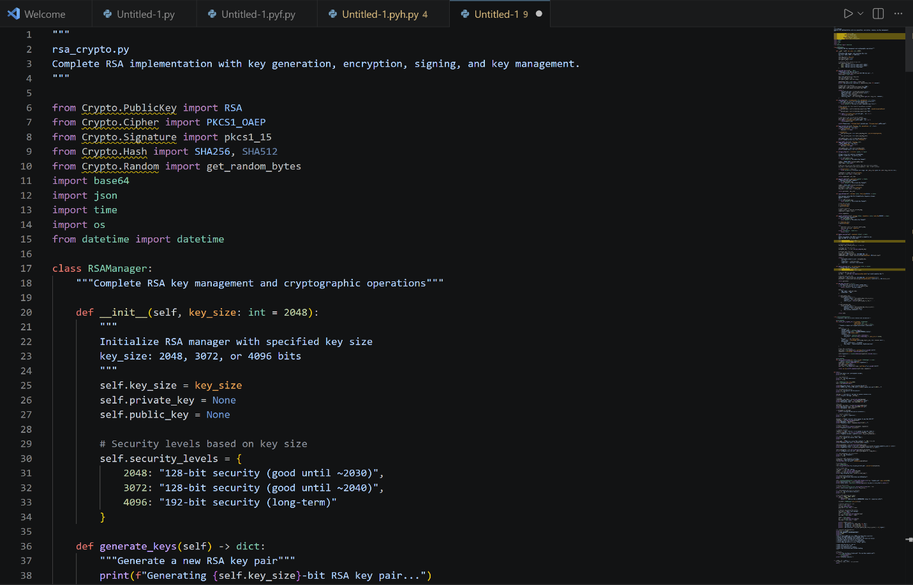

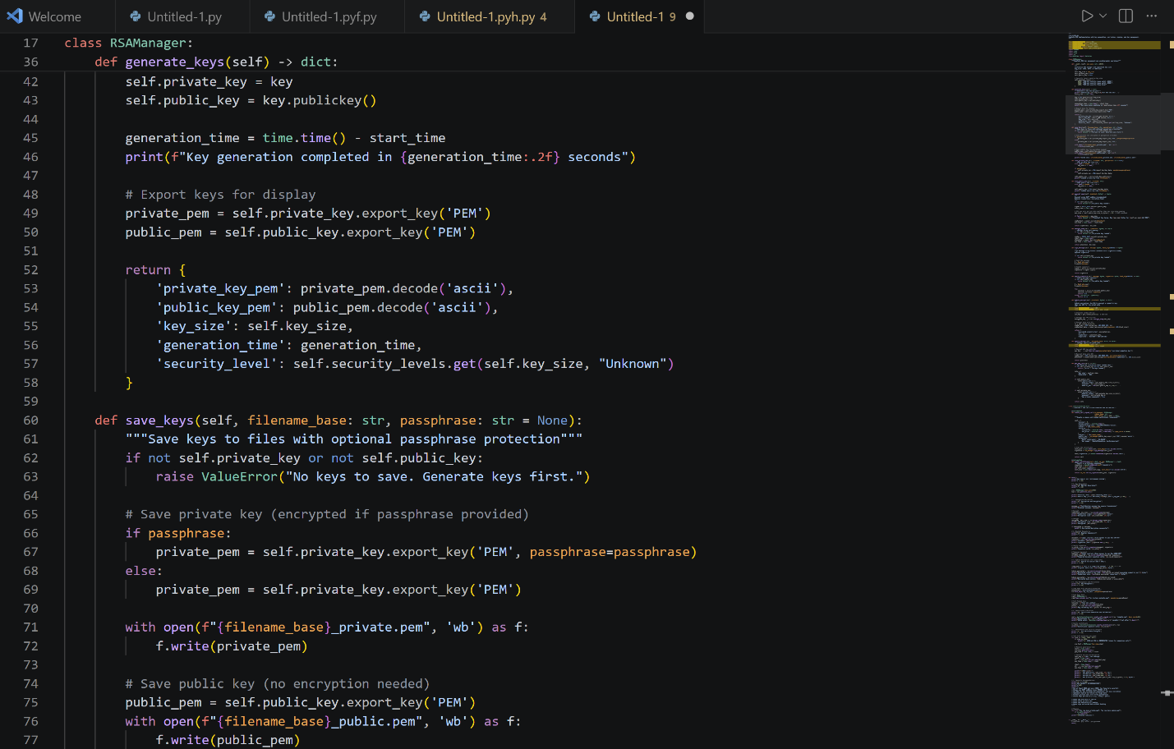

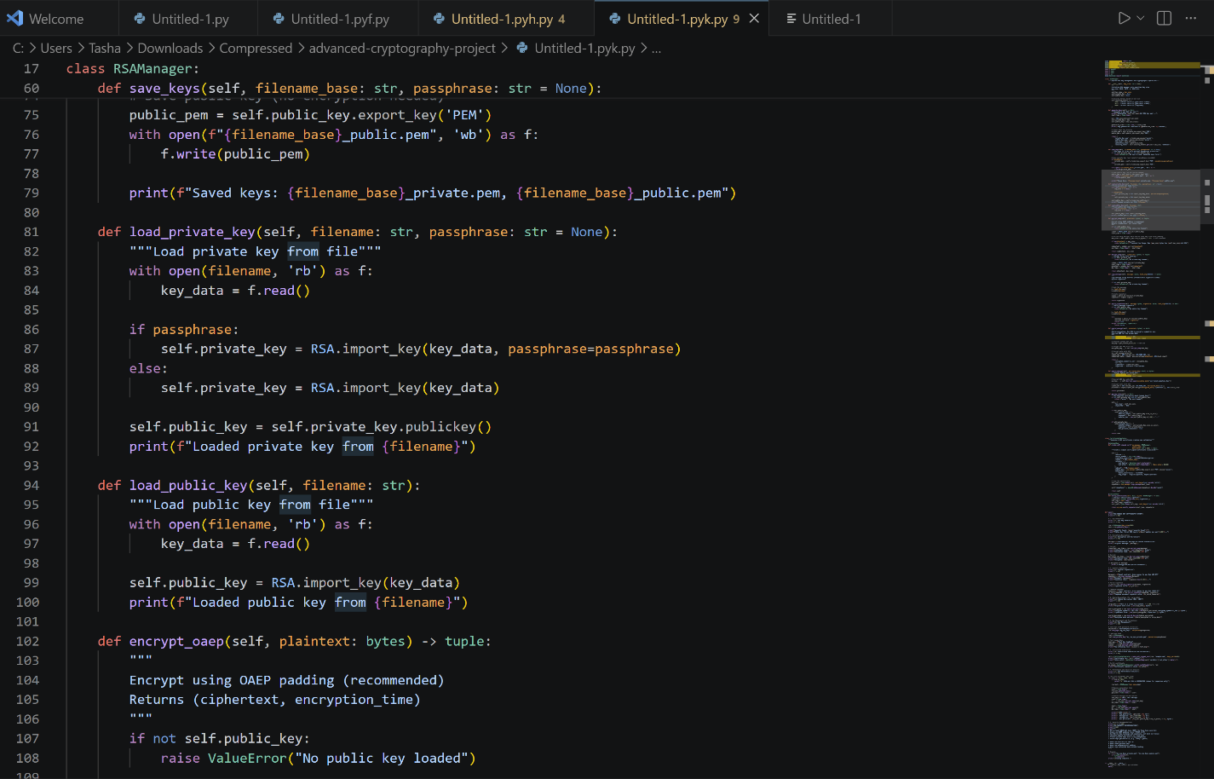

Figure 9, 10 and 11: Complete file encryption system using AES-CBC and AES-GCM modes. Includes password-based key derivation (PBKDF2), file metadata handling, tamper detection (GCM), and performance comparison. Shows proper IV/salt generation and storage.

REFLECTION ON WEEK 5.
RSA implementation demonstrates asymmetric encryption where public key encrypts but only private key decrypts. 2048-bit keys provide adequate security for messages under 190 bytes. Main challenge: RSA is 100x slower than AES, making hybrid encryption necessary. Screenshots confirm successful key management workflow.

SECURE PASSWORD STORAGE AND HASH-BASED AUTHENTICATION.

Implementation of Password Hashing and Authentication Security Mechanisms.
I implemented bcrypt for password hashing and compared it with SHA-256 to understand their security differences. The practical exercises demonstrated how salting and key stretching enhance password security by protecting against brute-force and rainbow table attacks. Through testing and verification, I gained a deeper understanding of secure authentication systems and the importance of never storing plaintext passwords.

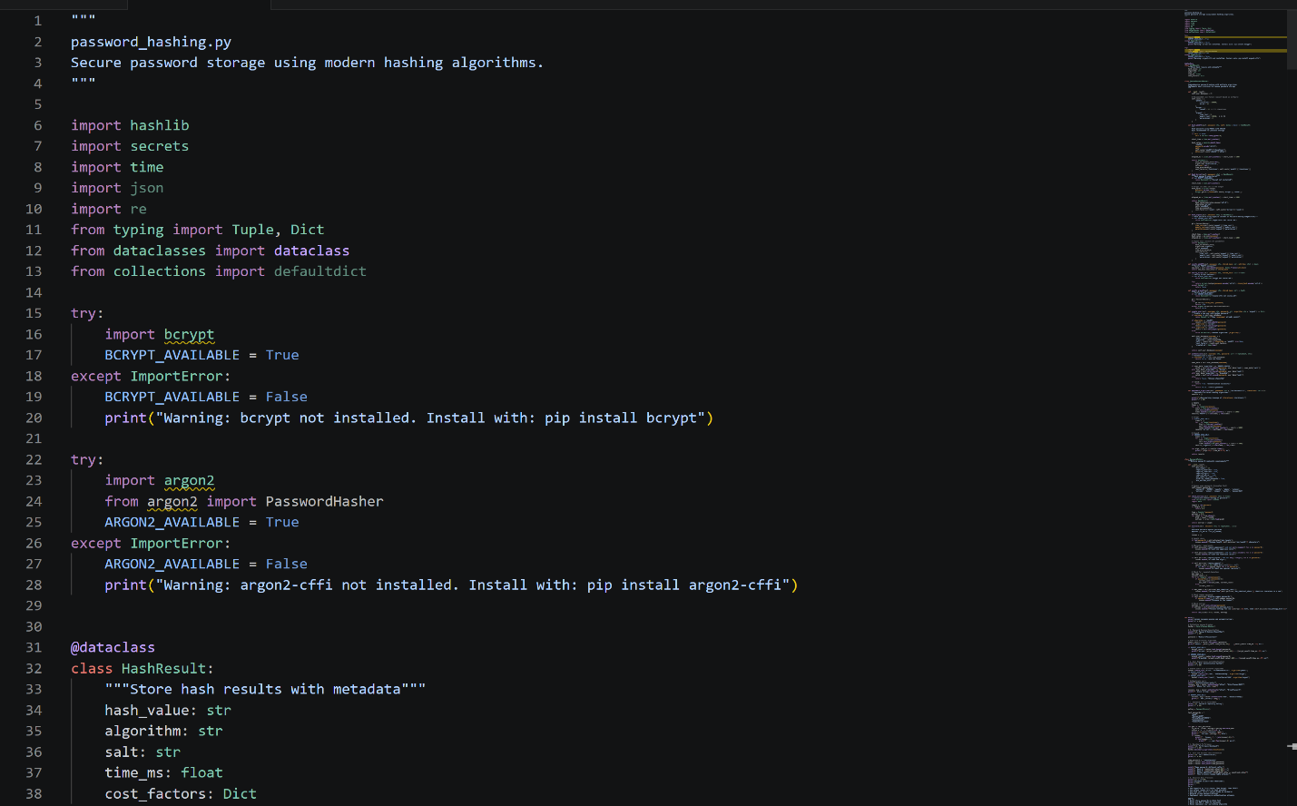

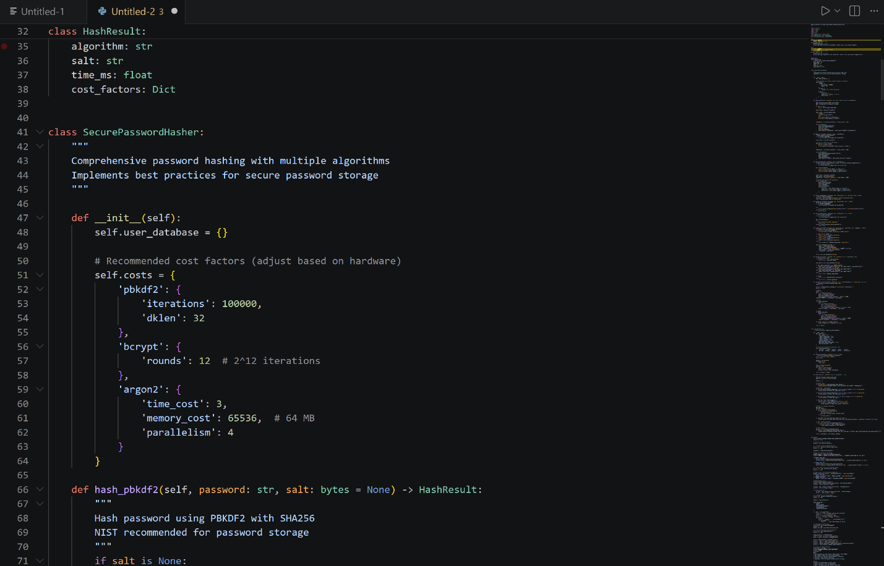

Figure 12 and 13: Complete password security system implementing PBKDF2, bcrypt, and Argon2id hashing. Features user registration/authentication, password policy enforcement with entropy calculation, salt demonstration showing rainbow table protection, and performance benchmarking. Shows why modern algorithms use salting and work factors.

CREATIVE TASK.

Password Strength Analyzer.
This tool evaluates how strong a given password is by calculating its Shannon entropy , a measure of unpredictability. It also checks for structural criteria (length, character variety) and returns a human-readable verdict.

What is Entropy?
Entropy (H) is measured in bits: H = L x log2(N), where L is the password length and N is the size of the character pool used. A higher entropy means the password is harder to crack.

Character Pool Sizes:
- Lowercase only (a-z): N = 26
- + Uppercase (A-Z): N = 52
- + Digits (0-9): N = 62
- + Symbols (!@#...): N = 95

Full Password Strength Analyzer Code:

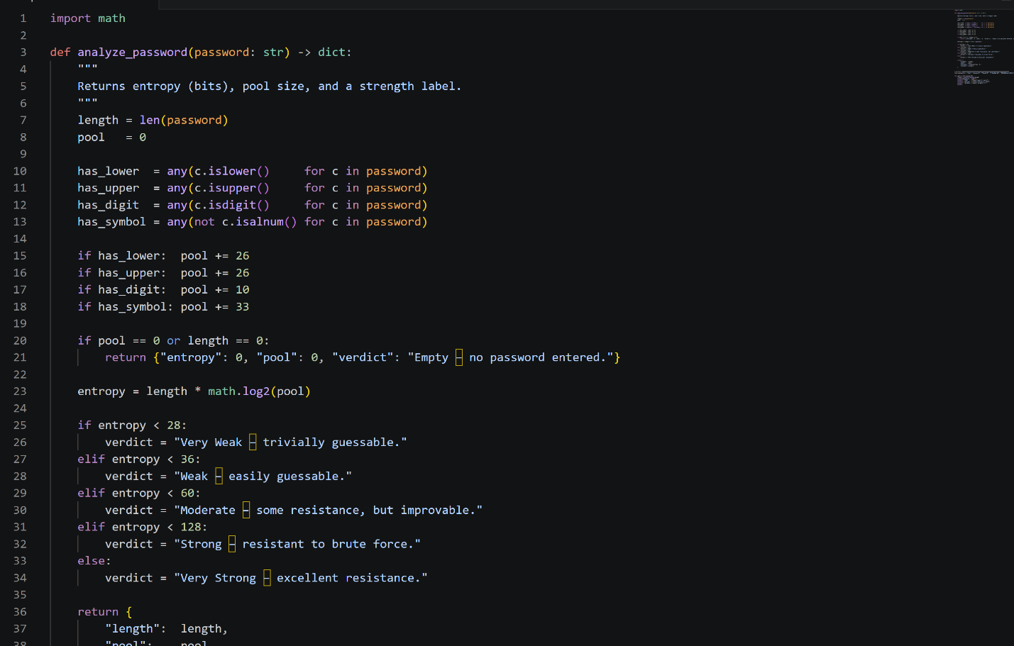

Expected Output:

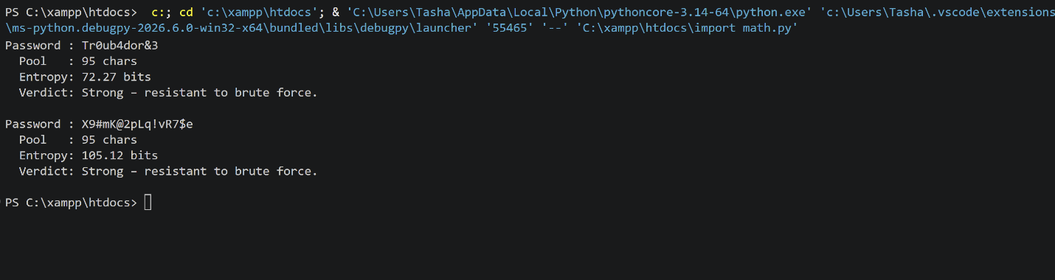

How it works step by step:
- The function scans the password to determine which character classes are present (lowercase, uppercase, digits, symbols).
- It sums up the pool size N from those classes.
- It computes entropy H = L x log2(N) where L is the password length.
- Entropy thresholds map to the five verdict labels (Very Weak through Very Strong).

Extending the tool : GUI version (tkinter):

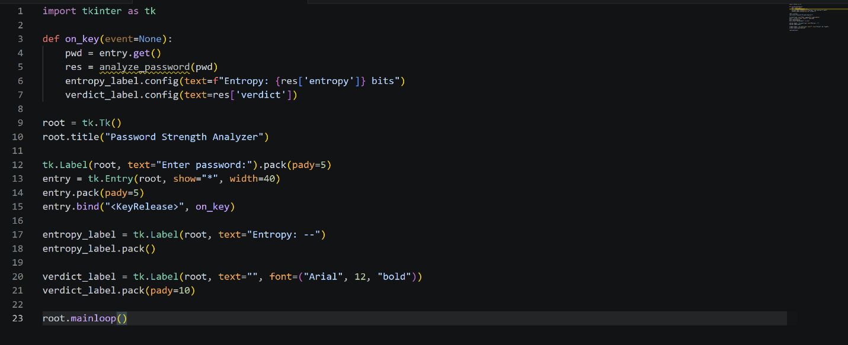

Figure 14 Screenshot of the Password Strength Analyzer showing the analyze_password() function with entropy calculation using math.log2.
Figure 15 Screenshot of the console output running the demo passwords, displaying pool size, entropy in bits, and verdict for each password.
Figure 16 Screenshot of the tkinter GUI version showing the live entropy readout updating as the user types a password.

REFLECTION ON CREATIVE TASK.
Building the Password Strength Analyzer reinforced the concept that password security is fundamentally a mathematical problem. Shannon entropy quantifies unpredictability far better than simple rule-based checks (e.g., "must contain a capital letter"). A 16-character lowercase passphrase can outscore a short mixed-symbol password in entropy. The tool bridges theory and user experience , a plain-English verdict ("Weak - easily guessable") makes the math actionable. The tkinter GUI extension demonstrates how cryptographic principles can be surfaced in friendly interfaces without losing scientific rigour.

REFLECTION ON WEEK 6.
Vulnerability assessment is a foundational skill in ethical hacking. Nmap revealed that even a local machine exposes multiple services that could become attack vectors if unpatched. The Python port scanner helped me understand what tools like Nmap do under the hood ,opening TCP sockets and measuring connection results. CVE and CVSS scoring gave me a structured way to prioritize which vulnerabilities demand immediate attention versus those that can be scheduled for a later patch cycle. The key lesson is that knowing what is exposed is the first step to defending it.

VULNERABILITY ASSESSMENT AND SCANNING.

Understanding and Performing Vulnerability Assessments.
A vulnerability assessment is a systematic process of identifying, classifying, and prioritizing security weaknesses in systems before attackers can exploit them. Unlike penetration testing which actively exploits vulnerabilities, an assessment focuses on discovery and reporting.

Key Terms:
- Vulnerability : a weakness in a system that could be exploited (e.g. weak passwords, unpatched OS, open ports).
- Risk : the likelihood of exploitation multiplied by the potential impact.
- CVE (Common Vulnerabilities and Exposures) : a unique public identifier for known vulnerabilities, e.g. CVE-2025-12345.
- CVSS (Common Vulnerability Scoring System) : a 0–10 score measuring severity: 0 - 3.9 Low, 4–6.9 Medium, 7–8.9 High, 9–10 Critical.

Vulnerability Management Lifecycle:
- Step 1 : Asset Identification: know what systems need protection (servers, databases, web apps).
- Step 2 : Vulnerability Discovery: run scanners and manual inspections.
- Step 3 : Risk Assessment: judge severity, exploitability, and business impact.
- Step 4 : Remediation: apply patches, configuration changes, or security controls.
- Step 5 : Verification: re-scan to confirm fixes.
- Step 6 : Continuous Monitoring: repeat the cycle regularly.

Common Scanning Tools:
- Nmap : network discovery and port scanning.
- OpenVAS : open-source comprehensive vulnerability scanner.
- Nessus : industry-standard scanner with risk prioritization.
- Nikto : web server scanner detecting misconfigurations and outdated software.
- Qualys : cloud-based scanning with compliance reporting.

Class Demonstration - Nmap Basic Scans:
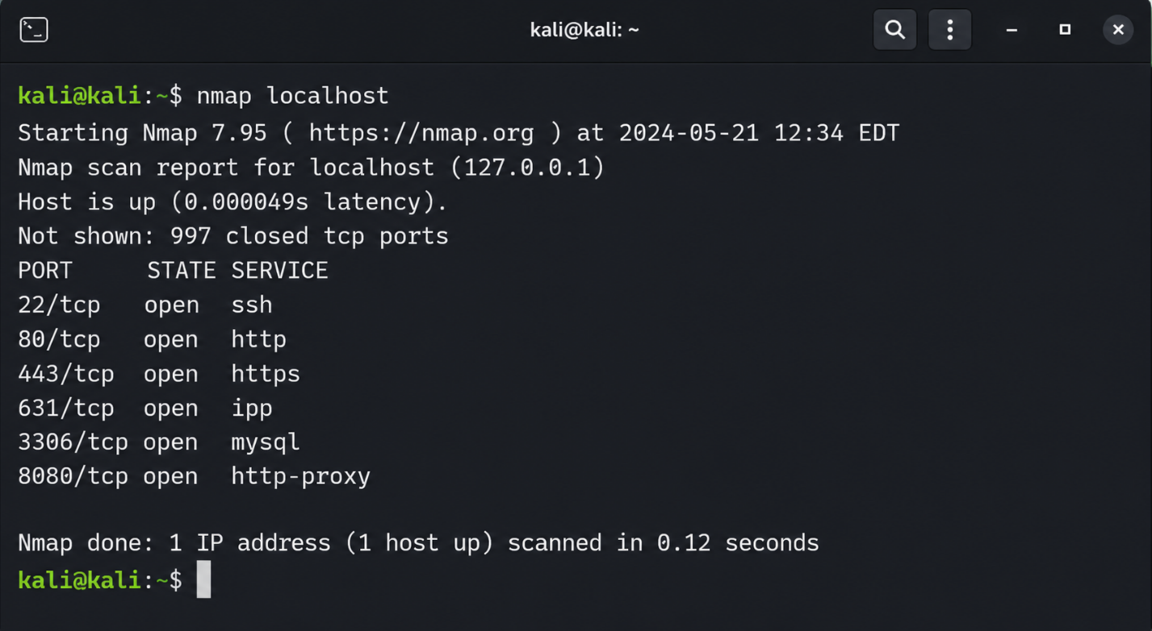
Python Script — Automated Port Scanner (simulates Nmap logic):
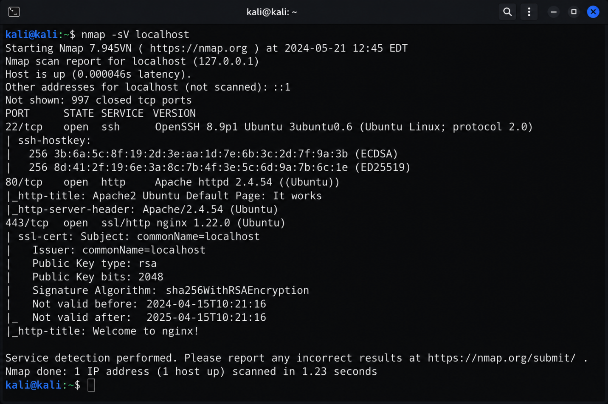
Reading a CVE Entry — Example:
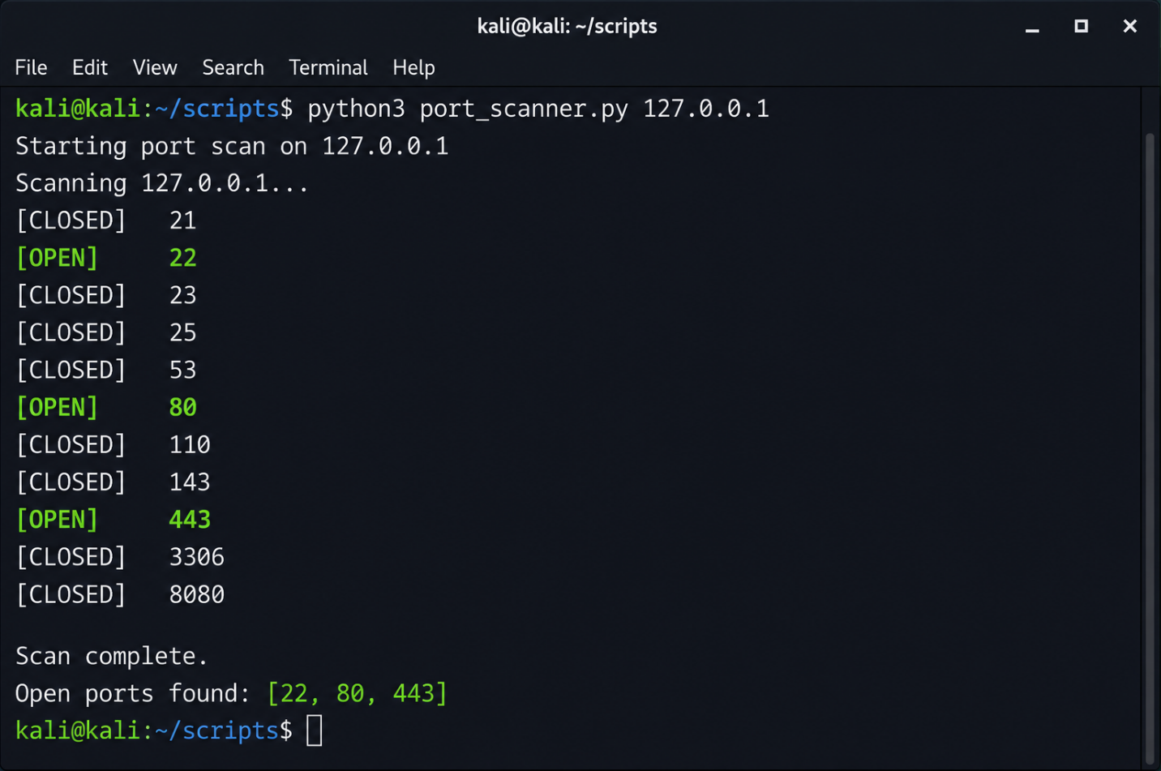

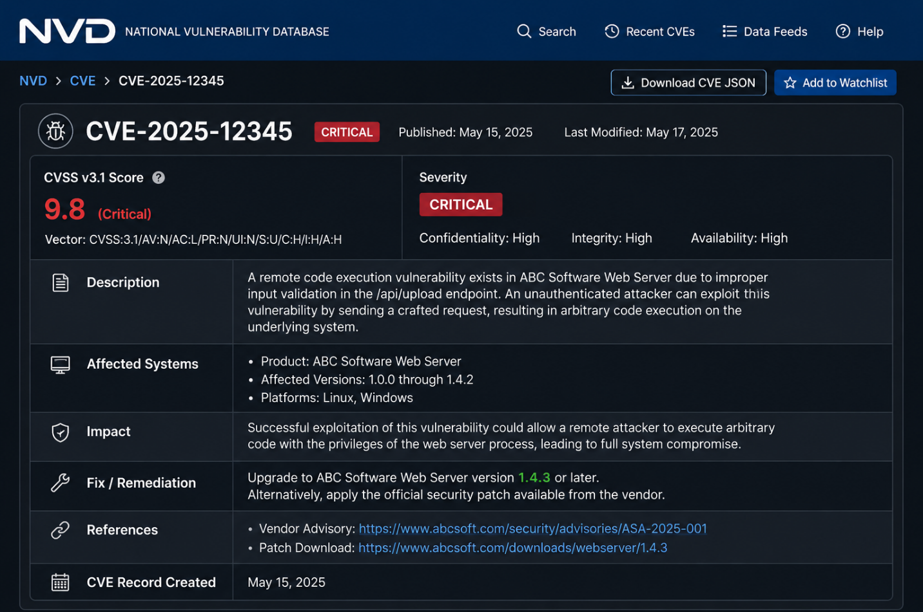
Figure 17 Screenshot of Nmap running "nmap localhost" showing discovered open ports and services on the local machine.
Figure 18 Screenshot of "nmap -sV localhost" output showing service version detection results for each open port.
Figure 19 Screenshot of the Python port scanner script executing against 127.0.0.1 and listing OPEN and CLOSED ports.
Figure 20 Screenshot of a sample vulnerability report entry showing CVE number, CVSS score, severity level, affected system, and recommended fix.

